**CODING CHALLENGE ASSESSMENT – PETPALS**

**TASKS:**

1. Provide a SQL script that initializes the database for the Pet Adoption Platform “PetPals”.



2. Create tables for pets, shelters, donations, adoption events, and participants.

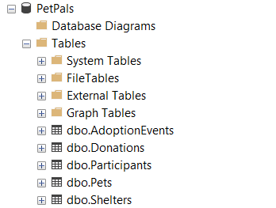

3. Define appropriate primary keys, foreign keys, and constraints.

The constraints have been defined successfully during the table creation.

For eg:

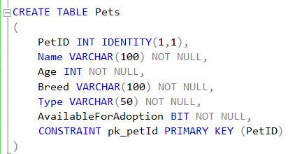

4. Ensure the script handles potential errors, such as if the database or tables already exist.

This SQL script:

1. Creates a database named "PetPals" if it doesn't exist.

2. Drops five tables ("Participants", "AdoptionEvents", "Donations", "Shelters", and "Pets") if they exist.

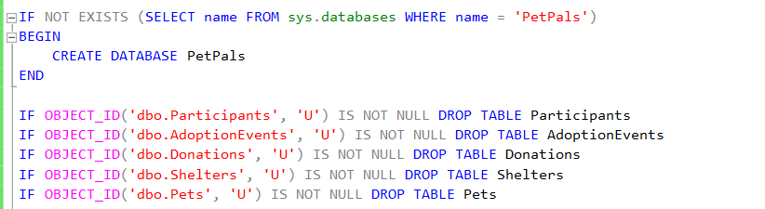

5. Write an SQL query that retrieves a list of available pets (those marked as available for adoption) from the "Pets" table. Include the pet's name, age, breed, and type in the result set. Ensure that the query filters out pets that are not available for adoption.

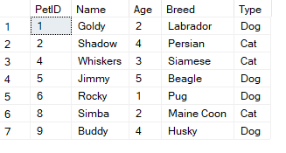

6. Write an SQL query that retrieves the names of participants (shelters and adopters) registered for a specific adoption event. Use a parameter to specify the event ID. Ensure that the query joins the necessary tables to retrieve the participant names and types.

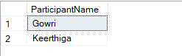

7. Create a stored procedure in SQL that allows a shelter to update its information (name and location) in the "Shelters" table. Use parameters to pass the shelter ID and the new information. Ensure that the procedure performs the update and handles potential errors, such as an invalid shelter ID.

- Stored procedures have not been taught yet.

8. Write an SQL query that calculates and retrieves the total donation amount for each shelter (by shelter name) from the "Donations" table. The result should include the shelter name and the total donation amount. Ensure that the query handles cases where a shelter has received no donations.

Altered the Donations table and added ShelterID as a foreign key to create a relationship, then updates some values to execute the query.

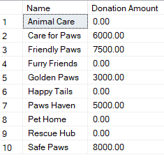

9. Write an SQL query that retrieves the names of pets from the "Pets" table that do not have an owner (i.e., where "OwnerID" is null). Include the pet's name, age, breed, and type in the result set.

Added an OwnerID column to the Pets table, updated some pets with owner information, and then found the pets that don’t have an owner.

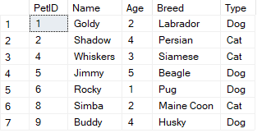

10. Write an SQL query that retrieves the total donation amount for each month and year (e.g., January 2023) from the "Donations" table. The result should include the month-year and the corresponding total donation amount. Ensure that the query handles cases where no donations were made in a specific month-year.

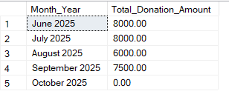

11. Retrieve a list of distinct breeds for all pets that are either aged between 1 and 3 years or older than 5 years.

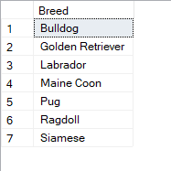

12. Retrieve a list of pets and their respective shelters where the pets are currently available for adoption.

Added a ShelterID column to the Pets table, linked it to the Shelters table, and updated pets with their shelter information. Then, retrieved the list of pets that are available for adoption and their shelter names.

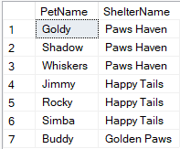

13. Find the total number of participants in events organized by shelters located in specific city. Example: City=Chennai.

The ShelterID column was added to the AdoptionEvents table and updated with shelter data. The query retrieves the total number of participants in adoption events organized by shelters located in Madurai.



14. Retrieve a list of unique breeds for pets with ages between 1 and 5 years.

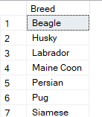

15. Find the pets that have not been adopted by selecting their information from the 'Pet' table.

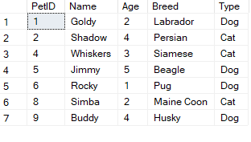

16. Retrieve the names of all adopted pets along with the adopter's name from the 'Adoption' and 'User' tables.

Since no User Table is available, let us use Participant table.

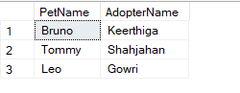

17. Retrieve a list of all shelters along with the count of pets currently available for adoption in each shelter.

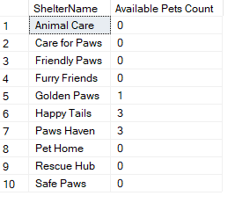

18. Find pairs of pets from the same shelter that have the same breed.

No pair of pets from the same shelter have the same breed.



19. List all possible combinations of shelters and adoption events.

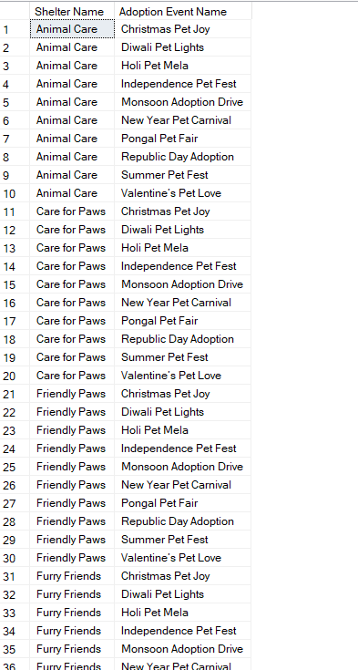

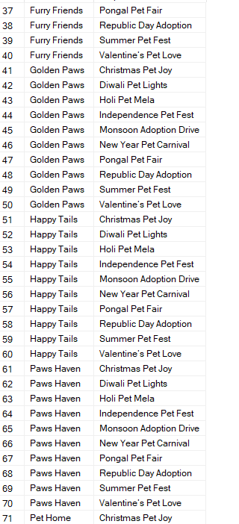

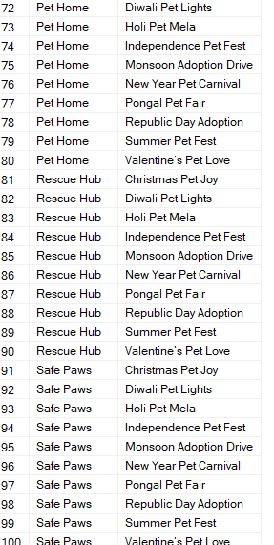

20. Determine the shelter that has the highest number of adopted pets.

